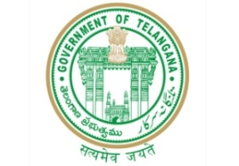**GOVERNMENT OF TELANGANA**

**TELANGANA TRIBAL WELFARE RESIDENTIAL DEGREE COLLEGE (GIRLS), MAHABUBABAD: MAHABUBABAD-DIST**

**https://www.ttwrdcs.ac.in/Mahabubabad**

**E-Mail Id:ttwrdcgirls.mahabubabad@gmail.com Cell No: 7901097695**

**ACADAMIC YEAR: 2024-27**

|  |  |  |  |  |  |
| --- | --- | --- | --- | --- | --- |
| S.NO | STUDENT NAME | FATHER NAME | DATE OF BIRTH | CASTE | PHONE NUMBER |
| 1 | A.SAGARIKA | A.Mallesh | 15-04-2007 | BC-D | 9652729557 |
| 2 | B.ANJALI | B.Bikku | 20-10-2006 | ST |  |
| 3 | B.SHIRISHA | B.Eeru | 18-09-2005 | ST | 8522876018 |
| 4 | B.VENNELA | B.Venkanna | 12-08-2005 | ST | 9908763341 |
| 5 | G.PUSHPA | G.Ravi | 30-07-2006 | ST | 9550450689 |
| 6 | G.SHIRISHA | G.Bhaskar | 16-08-2007 | ST | 9676648910 |
| 7 | G.YAMUNA | G.Amru |  | ST | 7032083780 |
| 8 | K.DIVYA PRASANNA | K.Ugendar | 12-03-2007 | ST | 8179207036 |